What is Apache Web Server?
The Apache HTTP Server is free and open-source cross-platform web server software, released under the terms of Apache License 2.0. Apache is developed and maintained by an open community of developers under the auspices of the Apache Software Foundation.
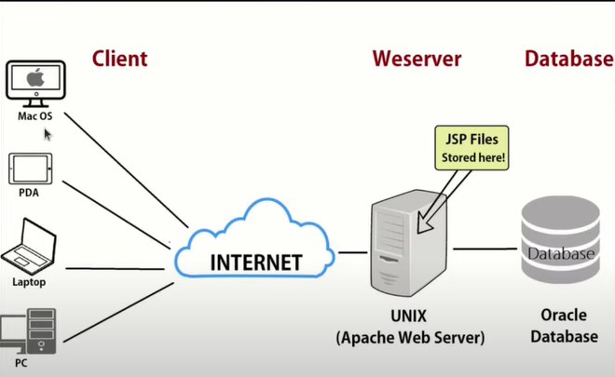

Apache Web Application Architecture
Apache is just one component that is needed in a web application stack to deliver web content. One of the most common web application stacks involves LAMP, or Linux, Apache, MySQL, and PHP.

Features of Apache Web Server
- Loadable dynamic modules
- Compatible with IPv6
- Supports HTTP/2
- FTP connections
- Gzip compression and decompression
- Perl, PHP, Lua scripts
- Load balancing
- Session tracking

Who Uses Apache Web Server?
Apache HTTP web servers are used by over 67% of all web servers in the world. Apache web servers are easy to customize environments; they’re fast, reliable, and highly secure. This makes Apache web servers a common choice by best-in-class companies.
Difference between the Apache Tomcat server and Apache web server:

Apache Tomcat Server | Apache Web Server
This server is a JSP/Servlet container. | This server is a HTTP server. It serves the files through the HTTP protocol.
It can handle both static pages and dynamic pages. The static pages are generated using HTML. The dynamic pages are generated using Servlet and JSP. | It can handle static pages which are generated using HTML. It can handle dynamic content which are coded in PHP, Ruby or other languages only through add-on modules offered by Apache or any other client.
It can be used only for hosting JAVA based code. | It can be used to host applications written in any programming language.
Apache Tomcat server is slower compare to Apache web server. | Apache Web server is faster compare to Apache Tomcat server.

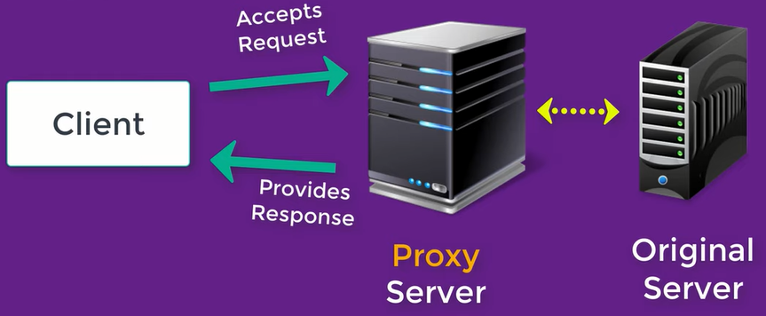
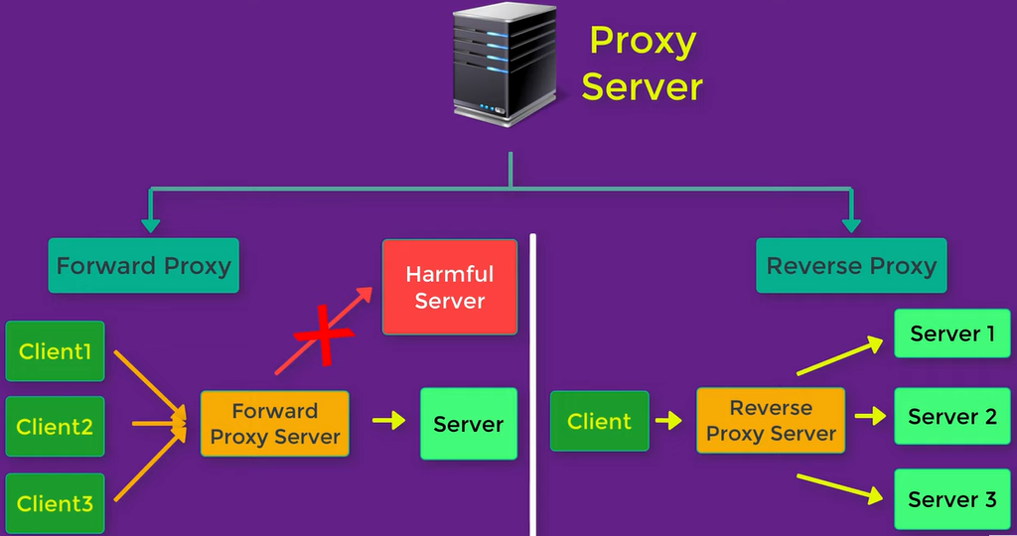

Forward proxy is known as client side firewall and reverse proxy is known as server side firewall

Apache HTTP Server as Forward proxy server
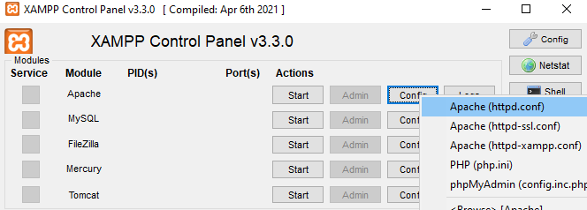
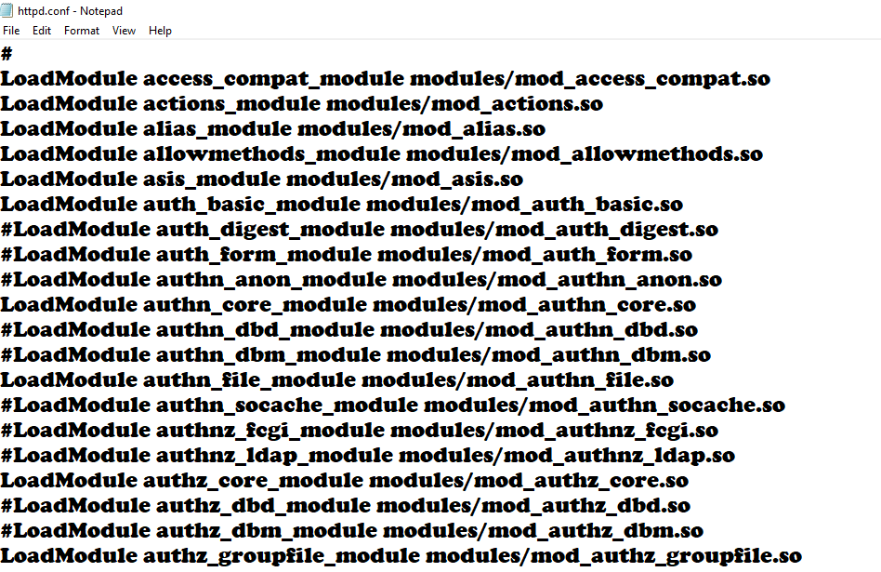
# means that module is disabled
To use apache as proxy server we have to enable some module
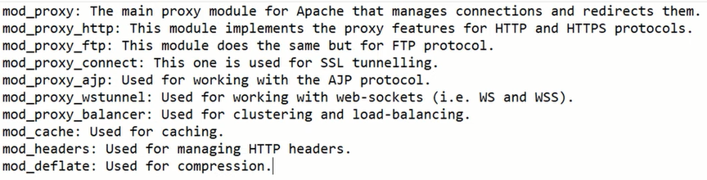
Uncomment all the module starting from mod_proxy
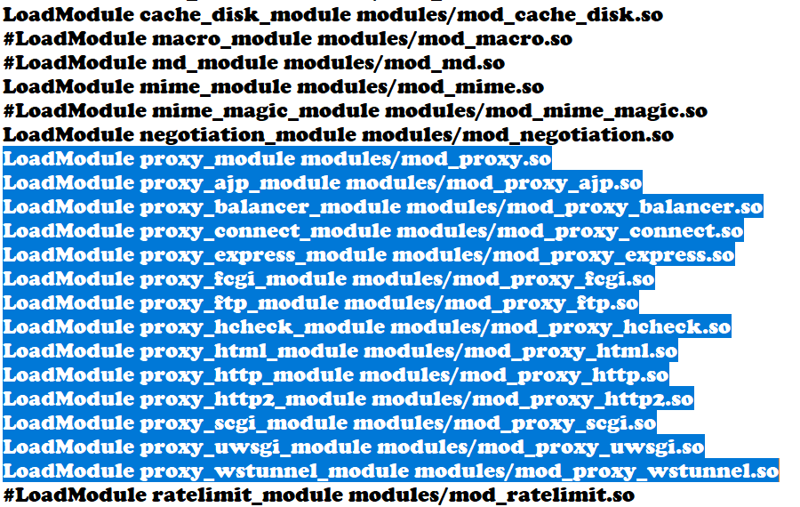
save changes

Go back to configuration and open
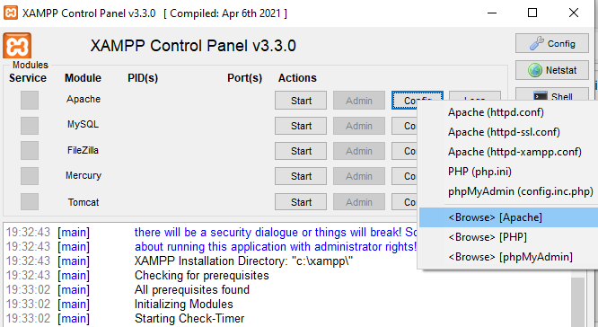
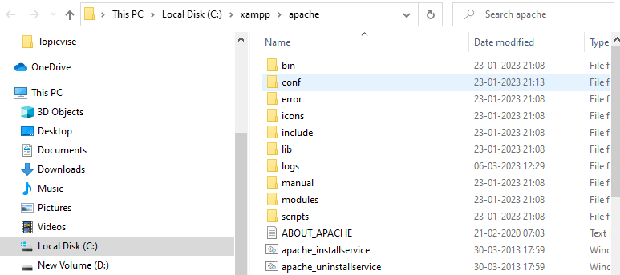
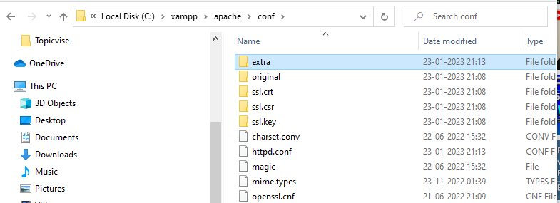
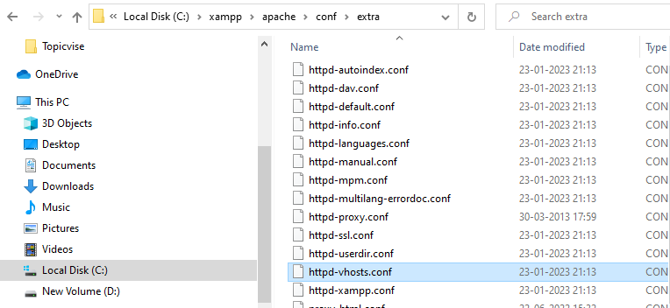
Create virtual host, add configuration to make the forward proxy working with apache
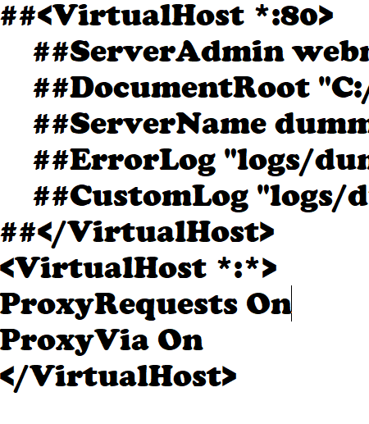
Save changes and start the server
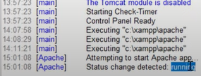
If there will be error like
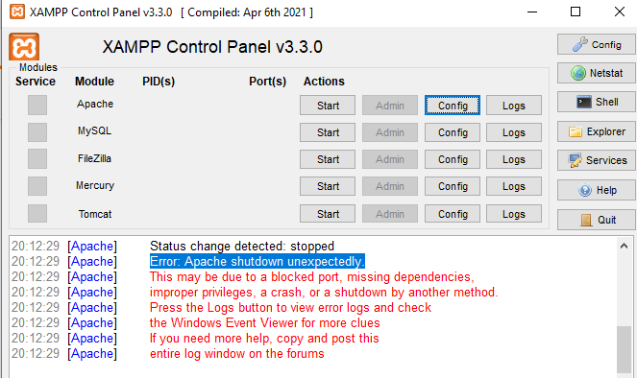
Follow these steps to resolve
Now set proxy for your internet as localhost with port 80(use windows+I for setting)
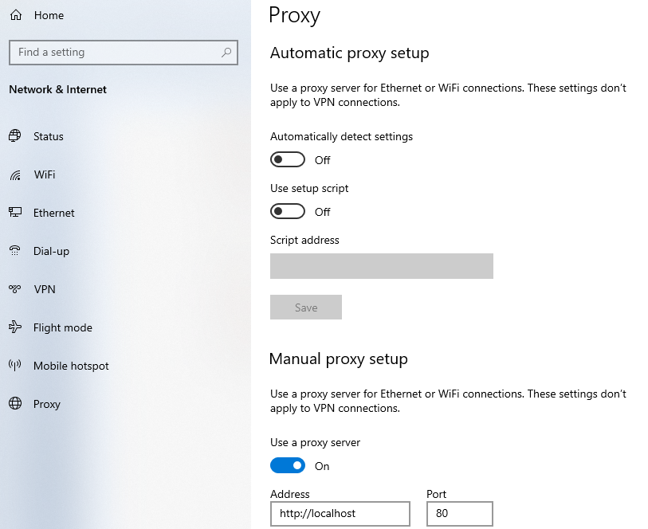
Open any website and see the apache access.log from log button it will display visited site here

